K. K. Wagh Institute of Engineering Education and Research, Nashik

Artificial Intelligence and Data Science
Academic Year 2026-27

MSPA (Q1-2026): Strengthening Final Year Projects through Industry & Alumni Mentorship

Industry/Alumni Mentor Interaction Record

1. Project Information
Project ID | PID-1
Project Title | RAP twin: Digital Twin Fabric Simulator for Distributed Systems
Project Guide | Prof. K. K. Deshmukh
Industry/Alumni Mentor | Sahil Badgujar
Mentor Organization & Designation | IOS developer at LTM

Interaction No | 1
Date | 11-10-2026
Time | 11 Am
Mode | Online
Venue / Platform | Zoom

2. Interaction Details

3. Objectives of the Meeting:
The objective of the meeting was to walk the industry mentor through RAP twin's current progress and dashboard, get feedback on the user interface, and get guidance on two proposed additions: expanded project documentation and a new recommendation-system feature to help users choose a scheduling algorithm.

4. Key Discussion Points:
- RAP twin's current progress and the live dashboard were demonstrated to the industry mentor.
- The mentor reviewed the dashboard's user interface and suggested minor UI/UX refinements for better clarity and polish.
- The mentor recommended expanding the project's documentation to cover both usage and technical/API details.
- The mentor suggested adding a recommendation-system feature that helps a user choose the most suitable scheduling algorithm/strategy for their workload.
- The team and mentor discussed how the recommendation-system feature could be scoped and implemented within the existing pluggable-planner architecture.

5. Suggestions Given by Mentor
Sr. No. | Suggestion
1
  Make minor UI/UX refinements to the dashboard — improve visual clarity, consistency, and overall polish.
2
  Expand the project documentation to cover both user-facing usage and technical/API details.
3
  Add a recommendation system that helps users choose the most suitable scheduling algorithm/strategy for their workload.
4
  Keep the dashboard's UI consistent and easy to use as the documentation and
  recommendation-system features are added.

6. Action Plan

Suggestion | Action to be Taken | Responsibility | Target Date
Apply minor UI/UX refinements | Review the dashboard UI and apply the mentor's suggested cosmetic/usability improvements. | All group members
Expand project documentation | Prepare expanded user-facing and technical/API documentation. | All group members
Add algorithm-recommendation feature | Design and implement a recommendation system that suggests a scheduling strategy based on job/workload characteristics. | All group members

7. Status of Previous Suggestions (For Interaction II onwards)

Suggestion | Status (Implemented / In Progress / Deferred) | Remarks

8. Overall Outcome of the Meeting:
The meeting provided valuable feedback on RAP twin's current state. The mentor's minor UI suggestions will be used to polish the dashboard, and the team agreed to expand the project's documentation and to design and build a new recommendation-system feature that helps users choose the right scheduling algorithm for their workload. These items will be taken up before the next interaction.

9. Next Meeting Schedule (If any)
Tentative Date: 18-10-2026
Agenda:
- Present progress on the expanded documentation and the new algorithm-recommendation feature.
- Discuss the progress achieved since the previous mentor meeting.
- Plan the upcoming development activities and task.
- Obtain mentor feedback and recommendations on the proposed implementation approach.

10. Signatures

Name | Signature
Sahil Badgujar | 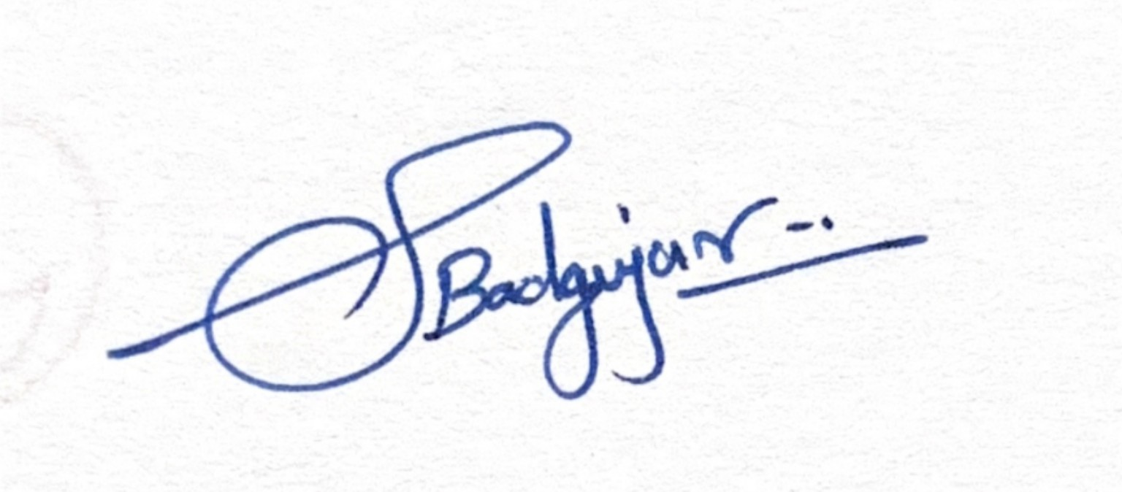
Prof. K. K. Deshmukh
Riaan Masoud Attar
Avanti Nitin Patil
Preet Prashant Boralkar

Attachments (if applicable)
☐ Meeting Photograph
☑ Screenshot (Online Meeting)
☐ Presentation Shared
☐ Updated Synopsis
☐ Other: __________________
